Power BI to Tableau Migration
~ Prathamesh Narayan Gupta & Rasalay Vishnuvardhan

Objectives
- Automation of conversion of Power BI dashboards to Tableau
- Reduction in time for the conversion
- Reducing dependency on manual interpretation and domain-specific expertise

Summary
Automated conversion of dashboards from one BI tool to another is a much-needed requirement for many firms. Manual conversion is error-prone and time consuming. Here, we provide a solution to convert Power BI dashboards to Tableau dashboards by automating the process using python scripts and excel files. While there is still some scope for improvement, the process outlined here greatly improves the efficiency, accuracy and time taken for the task; something which was not possible manually. The only manual effort needed is when reviewing the final results.

Dependencies
- Power BI Dashboard in “.pbix” format
- Tableau
- Python (With support for Jupyter Notebooks)
- MS Excel
- Selenium Chrome driver

Code Link
Power BI to Tableau Code Script
Negatives of the approach
- In dashboards, some charts may be visible only after clicking a certain button. The filters for these hidden charts do not get extracted and hence that needs to be done manually. This is because the button that reveals those charts might not be the same in all dashboards and looking for such a button might result in wrong buttons getting clicked. An example is shown below.
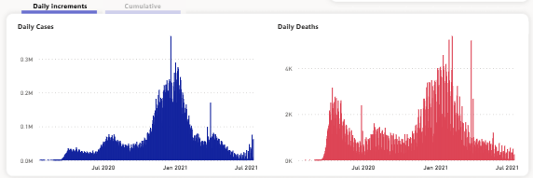

2) The SVG Class types of charts might help in pointing to the corresponding charts of those filters but may lead to confusion regarding which charts they refer to. There can be multiple charts of the same type in a dashboard.
3) To extract filters, embedded links of the dashboards are needed. For creating embedded links, a licensed version of Power BI is required.
Workflow

A Python script is used to extract all the metadata except filters from Power BI dashboards (“.pbix” files). The output excel file has the same name as the dashboard. We get the following information in the output excel file:
- Tables
- Schema
- DAX Measures (Along with converted Tableau equivalents)
- DAX Columns
- Relationships
- Filters
For filters, the script uses embedded links of dashboards to open them in a Chrome browser window using selenium module in python. After opening the embedded link, depending on the dashboard’s ownership, it may require you to sign in. A period of 30 seconds is provided for that. Then it goes to each chart individually and extracts its filters and filter types. These are stored in the ‘Filters’ sheet of the output excel file.
Conversion of DAX Queries into Tableau Expressions
This python script has conversion rules for more than 100 commonly used DAX expressions. In the DAX Measures pandas dataframe, there is a column “Expression” for DAX expressions.
When the python interpreter finds the column “Expression” in DAX Measures, it runs the conversion function and converts the DAX expressions into equivalent tableau calculations.
A column “Tableau Equivalents” is created beside the “Expression” column and the corresponding tableau calculations are added beside the DAX expressions in the dataframe. Then this dataframe is written to the output excel sheet.
The script uses regular expressions to match the DAX expressions and convert them into corresponding tableau calculations.

Time Analysis

Task | Manual Path Time | Automated Path Time | Time Saved | Efficiency Gain
Extracting the Metadata | 30 to 45 minutes | 3 minutes | 27 to 42 minutes | 90% to 93.3%
Converting the DAX Expressions (Actual time depends on the number) | 40 to 50 minutes | 2 minutes | 38 to 48 minutes | 95% to 96%
Writing metadata to the Excel file | 10 to 15 minutes | 1 minute | 9 to 14  minutes | 90% to 93.3%
Reviewing the Tableau Equivalents * | 5 minutes | 15 to 20 minutes | -10 to -15 minutes (Delay) | No Gain
Total Estimated Time | 85 to 115 minutes | 21 to 26 minutes | 64 to 89 minutes | 75.3% to 77.4%

*Reviewing the converted equivalents requires less time in the Manual Path than in the automated path because the conversion is done manually, so little to no reviewing is needed. But when conversion is done automatically, a significant number of conversions might need to be reviewed to ensure correctness.

Sample Dashboards Visualizations Created
Once we convert the Power BI DAX Expressions into Tableau calculations, we can use the same calculations to replicate the same visualizations in Tableau with the respective filters. Some sample illustrations of the conversion are shown below:

Power BI Dashboards | Converted Tableau Dashboards
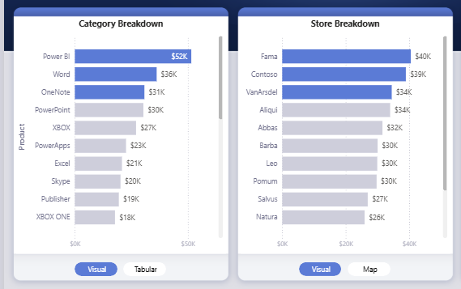 | 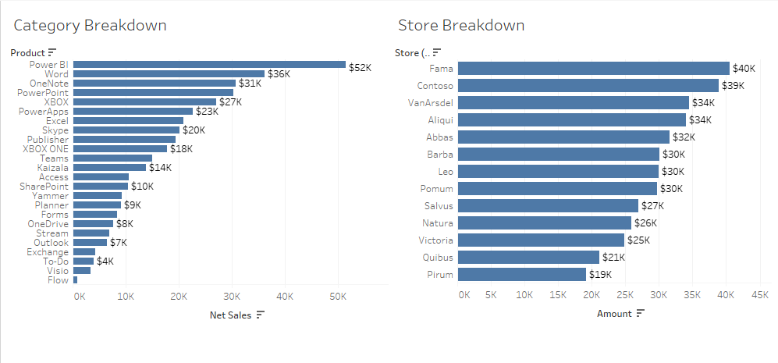
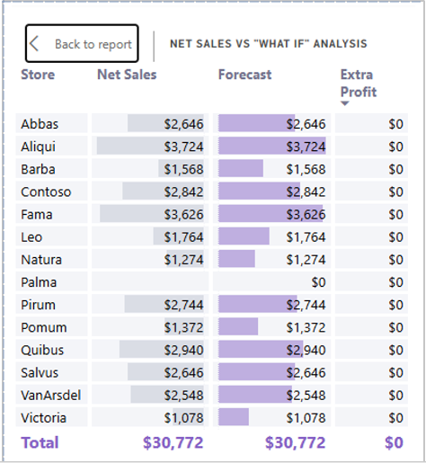 | 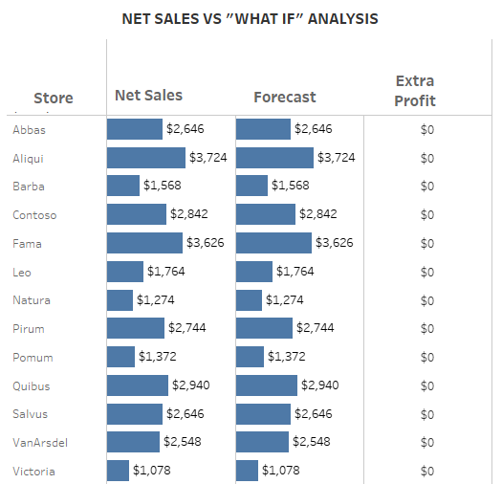
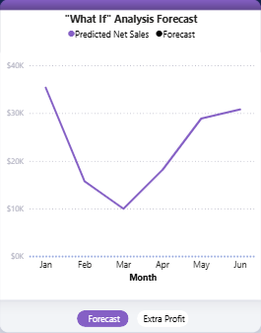 | 